System Analysis & Design
(AI Study Platform for All Learners)

Table of Contents
1. Problem Statement & Objectives
1.1 Use Case Diagram & Descriptions
1.2 Functional & Non-Functional Requirements
1.3 Software Architecture

2. Database Design & Data Modeling
2.1 Entity-Relationship Diagram (ERD)
2.2 Logical Schema
2.3 Physical Schema

3. Data Flow & System Behavior
3.1 Data Flow Diagram (DFD)
3.2 Sequence Diagrams
3.3 Activity Diagram
3.4 State Diagram
3.5 Class Diagram

4. UI/UX Design & Prototyping
4.1 Wireframes & Mockups
4.2 UI/UX Guidelines

5. System Deployment & Integration
5.1 Technology Stack
5.2 Deployment Diagram

6. Additional Deliverables
6.2 Testing & Validation
6.3 Deployment Strategy
1.Problem Statement & Objectives

- Use Case Diagram & Descriptions:
Use Case :
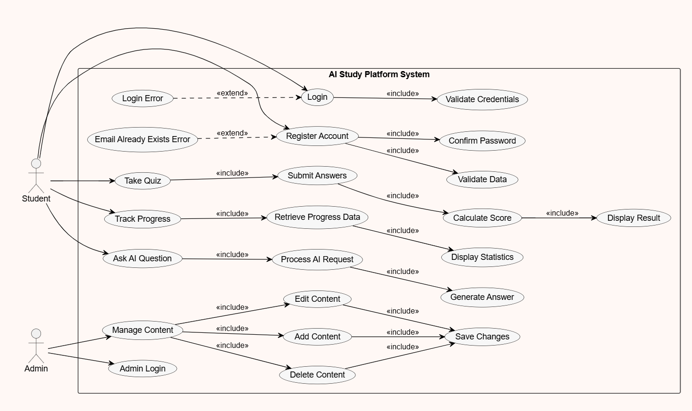

- Functional & Non-Functional Requirements:

Functional Requirements
1.User Management
_The system shall allow users to register using email and password.
_The system shall allow users to log in and log out securely.
_The system shall allow users to set up a profile (education level, learning goals, preferred style).

2.Document Management
_The system shall allow users to upload study materials (PDF, DOCX, TXT).
_The system shall validate uploaded files (format, size, corruption) before processing.
_The system shall detect and reject duplicate document uploads.
_The system shall parse and extract text, tables, and headings from uploaded documents.
_The system shall chunk documents into structured segments and generate embeddings.

3.AI Features
_The system shall allow users to ask questions about their uploaded documents via a chat interface.
_The system shall generate an automatic structured summary of any uploaded document.
_The system shall generate adaptive multiple-choice and short-answer quizzes based on document content.
_The system shall provide step-by-step explanations for complex concepts.
_The system shall evaluate user quiz answers and provide feedback with mistake analysis.
_The system shall use RAG to retrieve relevant document sections before generating any response.
_The system shall use an Agentic AI (Planner, Retriever, Executor, Verifier) to handle user requests.

4.Accessibility
_The system shall provide a simplified explanation mode for learners with different needs.
_The system shall support keyboard navigation and screen reader compatibility (ARIA).
_The system shall support RTL (Right-to-Left) display for Arabic users.

Non-functional Requirements
1.Performance Requirements
_The system shall respond to user interactions within ≤ 2 seconds for 90% of requests.
_The AI chatbot shall generate responses within ≤ 3 seconds under normal conditions.
_The platform shall support at least 200 concurrent users without significant performance degradation.
_The system shall efficiently handle multiple modules (notes, chatbot, tasks) running simultaneously.
_Page load time shall not exceed 3 seconds on standard internet connections.
_The system shall support scalable architecture to allow future expansion (adding new AI tools).

2.Security Requirements
_All communication shall be secured using HTTPS (TLS encryption).
_The system shall implement secure authentication and authorization mechanisms.
_User data (notes, chats, files) shall be stored securely and protected from unauthorized access.
_Passwords shall be hashed using strong algorithms (e.g., bcrypt).
_The system shall implement role-based access control (RBAC).
_Protection against common vulnerabilities shall be ensured, including:
- SQL Injection
- Cross-Site Scripting (XSS)
- Cross-Site Request Forgery (CSRF)
_User sessions shall expire after 30 minutes of inactivity (while ensuring that all user data (notes, chats, and tasks) remains can be accessed upon re-login).

3.Usability Requirements
_The interface shall be clean, organized, and intuitive
Users shall be able to navigate between features .
_The system shall allow users to start using core features within ≤ 3 clicks.
_The platform shall be fully responsive across all devices (desktop, tablet, mobile).
_Drag-and-drop functionality shall be supported for organizing content (optional but strong feature).
_The system shall provide real-time feedback (loading states, success/error messages).
_The design shall minimize cognitive load and follow UX best practices.

4.Reliability Requirements
_The system shall maintain an uptime of at least 97%.
_The system shall ensure that all user data (notes, chats, tasks) is saved without loss.
_The system shall support automatic data backup and recovery mechanisms.
_The platform shall handle failures gracefully without affecting the overall user experience.
_The system shall recover from failures within ≤ 5 minutes.
_The system shall ensure consistency between different modules (e.g., linked notes and chatbot responses).

- Software Architecture:
A high-level view of the system components and how they interact, following a Layered Architecture style. The platform is organized into four distinct layers, each with clear responsibilities.
Layers overview
• Frontend layer — React + Tailwind CSS. Provides the chat interface, file upload, quiz viewer, and summary panel.
• API layer — FastAPI backend. Exposes four main endpoints: /upload_document, /chat, /summarize, and /generate_quiz.
• AI layer — LangChain + LangGraph. Implements Agentic AI with four roles (Planner, Retriever, Executor, Verifier) plus Guardrails and LLM routing.
• Database layer — Supabase (PostgreSQL + pgvector). Stores users, documents, text chunks with embeddings, and quiz results.

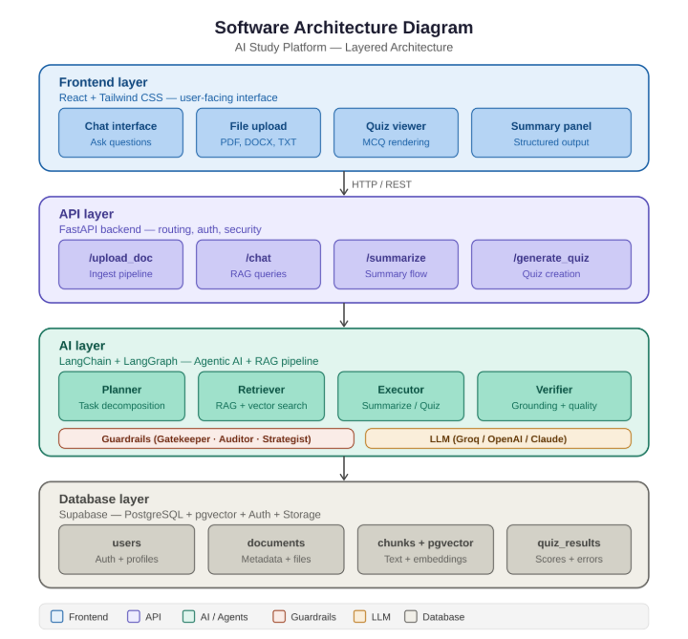

2. Database Design & Data Modeling
- ER Diagram (Entity-Relationship Diagram):
1. Entity-Relationship Diagram (ERD)
The Entity-Relationship Diagram (ERD) provides a comprehensive overview of the system's data architecture. The model is designed to be polymorphic, supporting both uploaded files (Documents) and interactive Notion-like workspace pages (Pages). It seamlessly integrates traditional relational structures with a Vector Database (pgvector) to empower advanced AI functionalities such as Retrieval-Augmented Generation (RAG) and Hierarchical Map-Reduce. 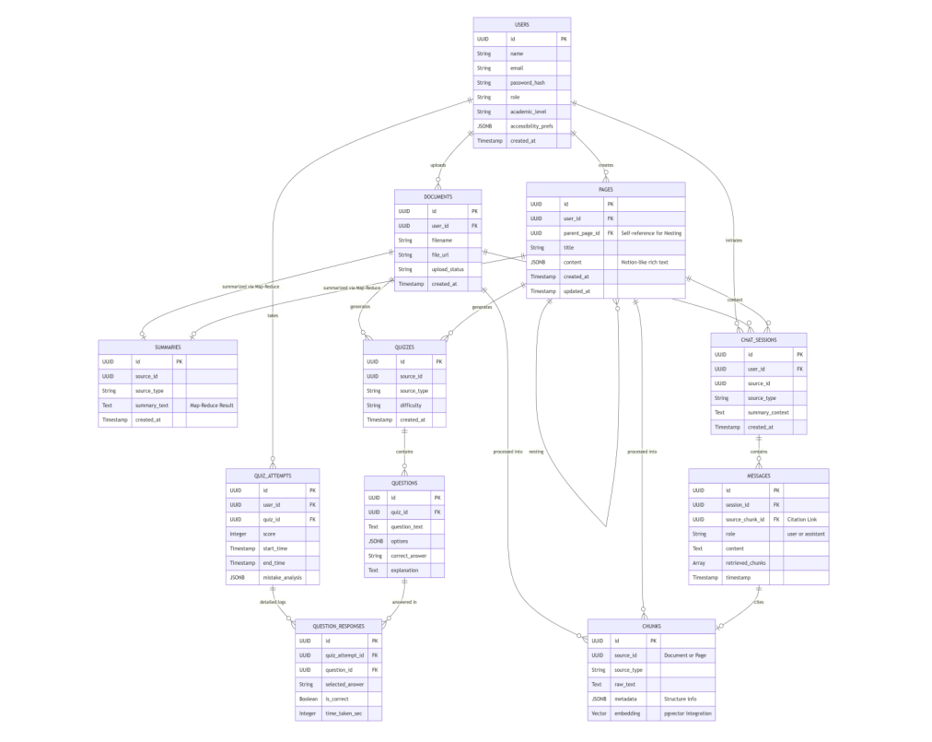

2.1 Core User Data & Notion-like Content
Attribute | Data Type | Constraints & Description
USERS
id | UUID | PK, Unique identifier.
email | TEXT | UNIQUE, NOT NULL.
password_hash | TEXT | NOT NULL.
academic_level | TEXT | NOT NULL, used for AI personalization.
PAGES
id | UUID | PK.
user_id | UUID | FK references USERS.
parent_page_id | UUID | FK references PAGES (Self-reference for nesting).
content | JSONB | Rich text data (Toggles, Headers, etc.).
DOCUMENTS
id | UUID | PK.
user_id | UUID | FK references USERS.
upload_status | TEXT | Triggers AI pipeline on 'completed'.

2.2 Content & Knowledge (AI & RAG System)
Attribute | Data Type | Constraints & Description
CHUNKS
id | UUID | PK.
source_id | UUID | Links to Document ID or Page ID.
source_type | TEXT | 'document' or 'page'.
embedding | VECTOR(1536) | Stores semantic embeddings for similarity search.
SUMMARIES
id | UUID | PK.
summary_text | TEXT | Stores Map-Reduce results to optimize token costs.

2.3 Interaction & Assessment (Quizzes & Chat)
Attribute | Data Type | Constraints & Description
CHAT_SESSIONS
id | UUID | PK.
source_id | UUID | Mandatory Context for RAG retrieval.
MESSAGES
id | UUID | PK.
source_chunk_id | UUID | FK references CHUNKS (For AI citation & traceability).
QUESTIONS
id | UUID | PK.
explanation | TEXT | Step-by-step reasoning generated by AI.
QUIZ_ATTEMPTS
id | UUID | PK.
mistake_analysis | JSONB | AI-generated qualitative feedback.
QUESTION_RESPONSES
id | UUID | PK.
time_taken_sec | INTEGER | Tracks time spent per question for granular analytics.

3. Physical Schema
This section provides the actual Data Definition Language (DDL) script compatible with PostgreSQL and the pgvector extension on the Supabase platform.

-- Enable pgvector for AI Embeddings [cite: 29, 30, 31]
CREATE EXTENSION IF NOT EXISTS vector; [cite: 31]

-- 1. Users Table [cite: 32, 33]
CREATE TABLE users ( [cite: 33]
id UUID PRIMARY KEY DEFAULT gen_random_uuid(), [cite: 35]
name TEXT NOT NULL, [cite: 36]
email TEXT UNIQUE NOT NULL, [cite: 37]
password_hash TEXT NOT NULL, [cite: 38]
role TEXT NOT NULL DEFAULT 'student', [cite: 39]
academic_level TEXT NOT NULL, [cite: 40]
accessibility_prefs JSONB DEFAULT '{}'::jsonb, [cite: 41]
created_at TIMESTAMP WITH TIME ZONE DEFAULT now() NOT NULL [cite: 42]
); [cite: 34]

-- 2. Pages (Notion-like) & Documents [cite: 43]
CREATE TABLE pages ( [cite: 44]
id UUID PRIMARY KEY DEFAULT gen_random_uuid(), [cite: 46]
user_id UUID NOT NULL REFERENCES users (id) ON DELETE CASCADE, [cite: 47]
parent_page_id UUID REFERENCES pages (id) ON DELETE CASCADE, [cite: 47]
title TEXT NOT NULL, [cite: 47]
content JSONB NOT NULL, [cite: 48]
created_at TIMESTAMP WITH TIME ZONE DEFAULT now() NOT NULL, [cite: 49]
updated_at TIMESTAMP WITH TIME ZONE DEFAULT now() NOT NULL [cite: 49]
); [cite: 45]

CREATE TABLE documents ( [cite: 50]
id UUID PRIMARY KEY DEFAULT gen_random_uuid(), [cite: 52]
user_id UUID NOT NULL REFERENCES users (id) ON DELETE CASCADE, [cite: 53]
filename TEXT NOT NULL, [cite: 54]
file_url TEXT NOT NULL, [cite: 55]
upload_status TEXT NOT NULL, [cite: 56]
created_at TIMESTAMP WITH TIME ZONE DEFAULT now() NOT NULL [cite: 57]
); [cite: 51]

-- 3. AI Chunks & Embeddings (Unified Table) [cite: 58, 59]
CREATE TABLE chunks ( [cite: 59]
id UUID PRIMARY KEY DEFAULT gen_random_uuid(), [cite: 60]
source_id UUID NOT NULL, [cite: 61]
source_type TEXT NOT NULL CHECK (source_type IN ('document', 'page')), [cite: 62]
raw_text TEXT NOT NULL, [cite: 63]
metadata JSONB, [cite: 64]
embedding vector (1536), [cite: 65]
CONSTRAINT fk_document FOREIGN KEY (source_id) REFERENCES documents (id) ON DELETE CASCADE DEFERRABLE INITIALLY DEFERRED, [cite: 66]
CONSTRAINT fk_page FOREIGN KEY (source_id) REFERENCES pages (id) ON DELETE CASCADE DEFERRABLE INITIALLY DEFERRED [cite: 67]
); [cite: 68]

-- HNSW Index for rapid semantic search [cite: 69, 70]
CREATE INDEX ON chunks USING hnsw (embedding vector_cosine_ops); [cite: 70]

-- 4. Summaries & Chat [cite: 71]
CREATE TABLE summaries ( [cite: 72]
id UUID PRIMARY KEY DEFAULT gen_random_uuid(), [cite: 74]
source_id UUID NOT NULL, [cite: 75]
source_type TEXT NOT NULL CHECK (source_type IN ('document', 'page')), [cite: 76]
summary_text TEXT NOT NULL, [cite: 77]
created_at TIMESTAMP WITH TIME ZONE DEFAULT now() NOT NULL [cite: 78]
); [cite: 73]

CREATE TABLE chat_sessions ( [cite: 79]
id UUID PRIMARY KEY DEFAULT gen_random_uuid(), [cite: 81]
user_id UUID NOT NULL REFERENCES users (id) ON DELETE CASCADE, [cite: 82]
source_id UUID NOT NULL, [cite: 83]
source_type TEXT NOT NULL CHECK (source_type IN ('document', 'page')), [cite: 84]
summary_context TEXT, [cite: 84]
created_at TIMESTAMP WITH TIME ZONE DEFAULT now() NOT NULL [cite: 85]
); [cite: 80]

CREATE TABLE messages ( [cite: 86]
id UUID PRIMARY KEY DEFAULT gen_random_uuid(), [cite: 88]
session_id UUID NOT NULL REFERENCES chat_sessions (id) ON DELETE CASCADE, [cite: 89]
source_chunk_id UUID REFERENCES chunks (id) ON DELETE SET NULL, [cite: 89]
role TEXT NOT NULL CHECK (role IN ('user', 'assistant')), [cite: 90]
content TEXT NOT NULL, [cite: 91]
retrieved_chunks UUID [] DEFAULT '{}', [cite: 92]
timestamp TIMESTAMP WITH TIME ZONE DEFAULT now() NOT NULL [cite: 93]
); [cite: 87]

-- 5. Quizzes & Analytics [cite: 94]
CREATE TABLE quizzes ( [cite: 95]
id UUID PRIMARY KEY DEFAULT gen_random_uuid(), [cite: 97]
source_id UUID NOT NULL, [cite: 98]
source_type TEXT NOT NULL CHECK (source_type IN ('document', 'page')), [cite: 99]
difficulty TEXT NOT NULL, [cite: 99]
created_at TIMESTAMP WITH TIME ZONE DEFAULT now() NOT NULL [cite: 100]
); [cite: 96]

CREATE TABLE questions ( [cite: 101]
id UUID PRIMARY KEY DEFAULT gen_random_uuid(), [cite: 103]
quiz_id UUID NOT NULL REFERENCES quizzes (id) ON DELETE CASCADE, [cite: 104]
question_text TEXT NOT NULL, [cite: 105]
options JSONB NOT NULL, [cite: 106]
correct_answer TEXT NOT NULL, [cite: 107]
explanation TEXT [cite: 108]
); [cite: 102]

CREATE TABLE quiz_attempts ( [cite: 109]
id UUID PRIMARY KEY DEFAULT gen_random_uuid(), [cite: 110]
user_id UUID NOT NULL REFERENCES users (id) ON DELETE CASCADE, [cite: 111]
quiz_id UUID NOT NULL REFERENCES quizzes (id) ON DELETE CASCADE, [cite: 112]
score INTEGER NOT NULL, [cite: 112]
start_time TIMESTAMP WITH TIME ZONE NOT NULL, [cite: 113]
end_time TIMESTAMP WITH TIME ZONE, [cite: 114]
mistake_analysis JSONB [cite: 115]
); [cite: 116]

CREATE TABLE question_responses ( [cite: 117]
id UUID PRIMARY KEY DEFAULT gen_random_uuid(), [cite: 118]
quiz_attempt_id UUID NOT NULL REFERENCES quiz_attempts (id) ON DELETE CASCADE, [cite: 118, 119]
question_id UUID NOT NULL REFERENCES questions (id) ON DELETE CASCADE, [cite: 120]
selected_answer TEXT, [cite: 120]
is_correct BOOLEAN NOT NULL, [cite: 121]
time_taken_sec INTEGER [cite: 122]
); [cite: 123]

4. Tables, Attributes, and Keys
Summary map of primary and foreign keys used to maintain referential integrity.
Table Name | Primary Key (PK) | Foreign Keys (FK)
users | id
pages | id | user_id -> users, parent_page_id -> pages
documents | id | user_id -> users
chunks | id | source_id -> documents OR pages
chat_sessions | id | user_id -> users, source_id -> documents OR pages
messages | id | session_id -> chat_sessions, source_chunk_id -> chunks
quizzes | id | source_id -> documents OR pages
questions | id | quiz_id -> quizzes
quiz_attempts | id | user_id -> users, quiz_id -> quizzes
question_responses | id | quiz_attempt_id -> quiz_attempts, question_id -> questions

5. Relationships and Normalization
The system architecture is designed to be both flexible and tightly coupled to support the specific needs of the AI engine.
- One-to-Many (1:M): A user can own multiple documents, workspace pages, and quiz attempts.
- Polymorphic Associations: AI-specific tables (chunks, summaries, quizzes, sessions) are not tied exclusively to a file. They link to a 'source_id' which can be either a PDF document or an interactive Notion-like page, providing high operational flexibility.
- Self-Referencing (1:M): The 'pages' table references itself to establish a hierarchical nesting structure, allowing for sub-pages and complex workspace organization.
5.2 Database Normalization Compliance
- First Normal Form (1NF): All data attributes are atomic. JSONB is utilized for variable-structured data like quiz options and rich-text content, which is the modern standard for PostgreSQL without violating schema atomicity.
- Second Normal Form (2NF): Every table adheres to 1NF and utilizes a single-column surrogate Primary Key (auto-generated UUIDs), ensuring no partial functional dependencies.
- Third Normal Form (3NF): The database avoids transitive dependencies. Total scores are stored in quiz_attempts, while granular responses and correctness are tracked in question_responses, allowing for optimal analytical performance and data consistency.

3. Data Flow & System Behavior

1. DFD (Data Flow Diagram):

- Level 0 :

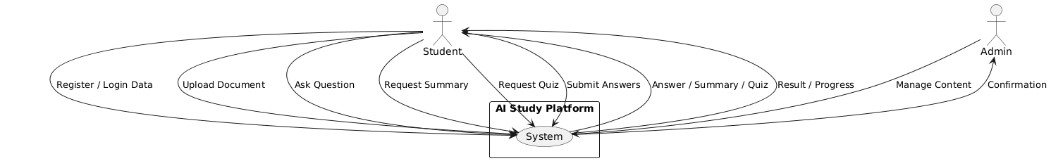

- Level 1 :

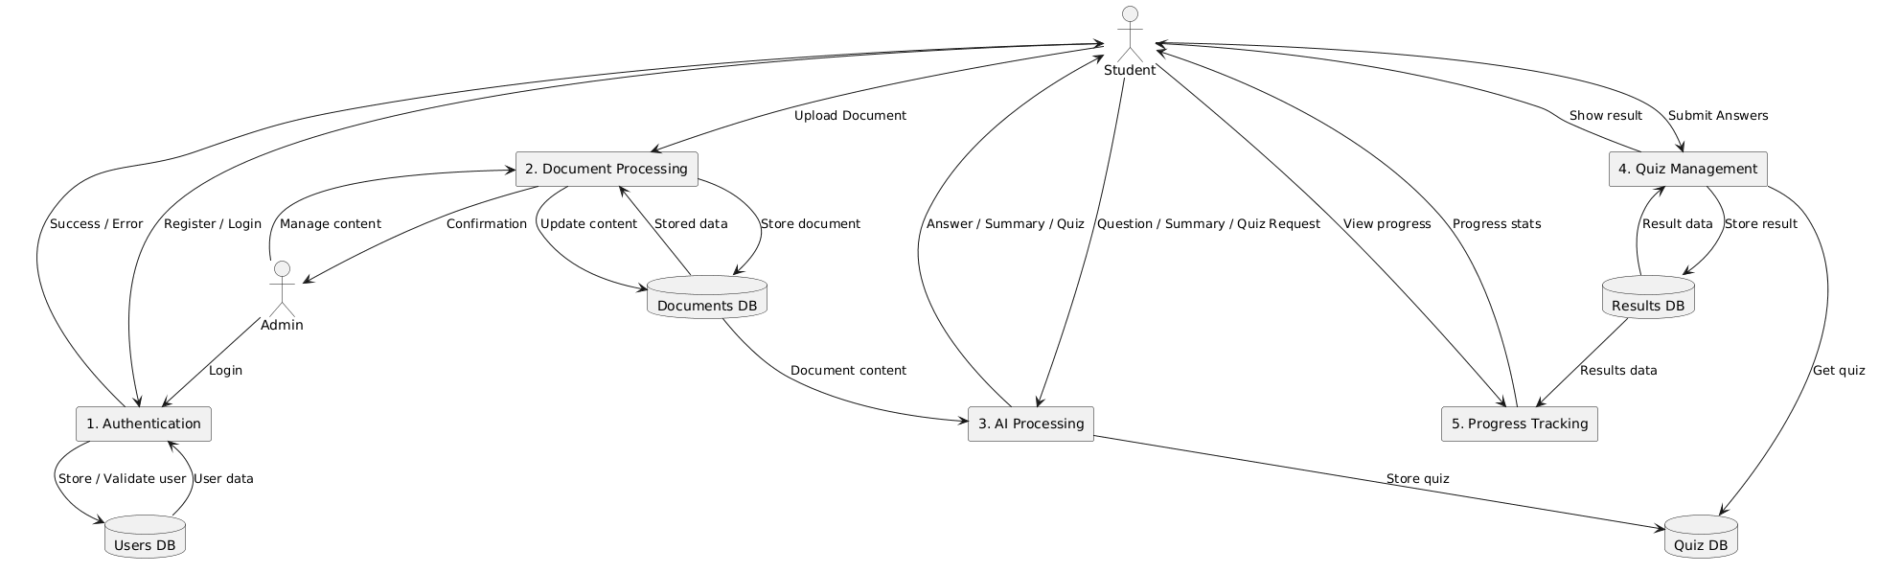

- Sequence Diagram :

- User Registration :
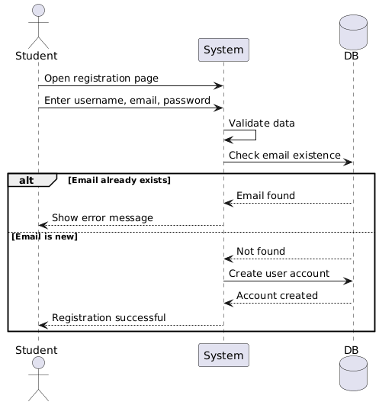

2. Class Diagram
Defines the structure of the system by showing the core classes, their attributes, methods, and relationships.
Core classes
• User — Stores profile data and handles authentication (register, login, updateProfile).
• Document — Represents an uploaded file. Linked to a user and contains many Chunks.
• Chunk — A text segment from a document, with its vector embedding for semantic search.
• Quiz + Question — A generated quiz linked to a document, composed of multiple questions with MCQ options.
• QuizResult — Tracks a user's attempt at a quiz, storing scores and errors.
• Agent (abstract) — Base class extended by Planner, Retriever, Executor, and Verifier.
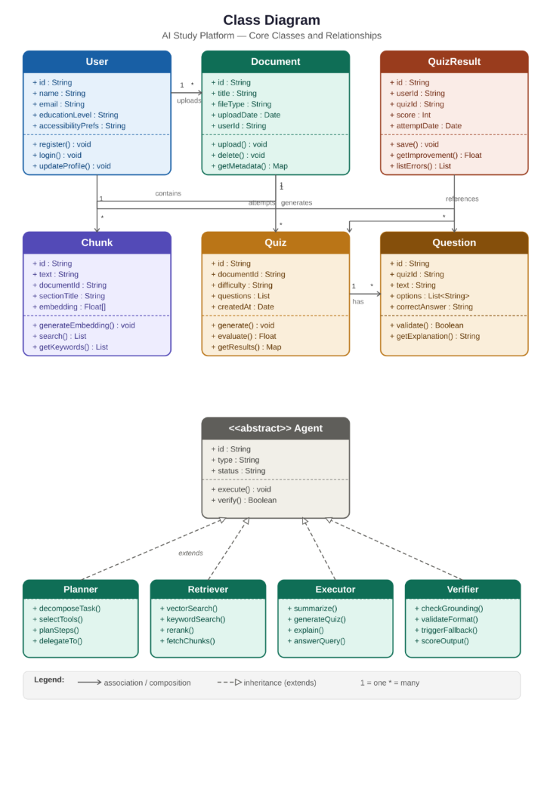

3. Activity Diagram
Visualizes the workflow of user actions within the system — from registration through document upload, AI processing, and smart learning interactions.
Key flows
• User registers or logs in and sets up their profile (education level, learning style, accessibility preferences).
• User uploads a document (PDF, DOCX, TXT). Frontend validates format and size; backend checks authentication, duplicates, and encoding. Invalid files are rejected immediately.
• Valid documents pass through the AI processing pipeline: Parse → Chunk → Embed → Store in Supabase.
• User can then request Chat (RAG-based Q&A), a Summary, or a Quiz. All outputs pass through the Guardrails layer before delivery.
• The user can continue with additional actions or end the session.
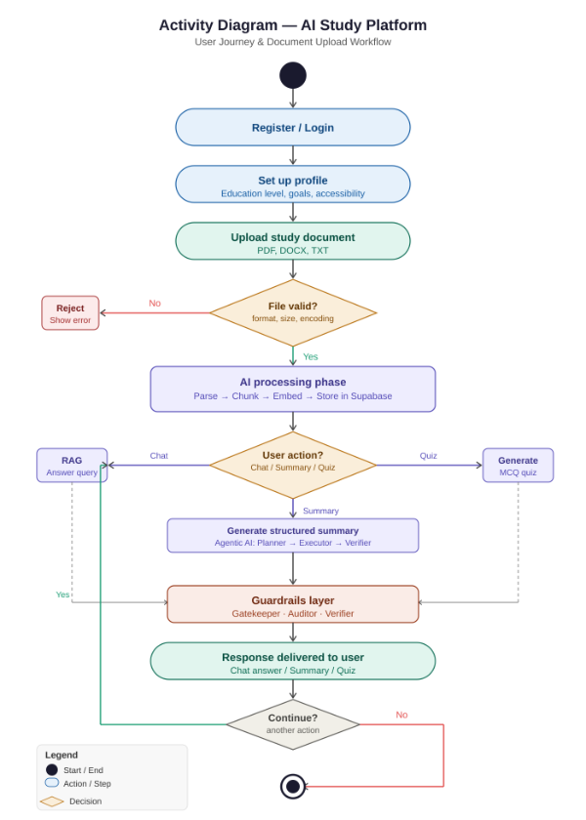

4. State Diagram
Represents the different states of a Document object and how it transitions between them — from initial upload through to being fully ready for AI queries.
Document states
• Uploaded — File received by the FastAPI backend. Entry action: store raw file.
• Validating — Backend security and integrity checks (authentication, duplicates, encoding). On failure → Rejected state.
• Parsing — Extract raw text, tables, and headings from the file.
• Chunking — Structure-aware segmentation into text blocks with metadata and keyword generation.
• Embedding — Each chunk is converted to a semantic vector using HuggingFace embedding models.
• Storing — All data (document metadata, chunks, embeddings) persisted to Supabase PostgreSQL + pgvector.
• Ready — Document is fully indexed and available for Chat, Summary, and Quiz interactions.
• Rejected / Error — Terminal states triggered by validation failure or pipeline errors.
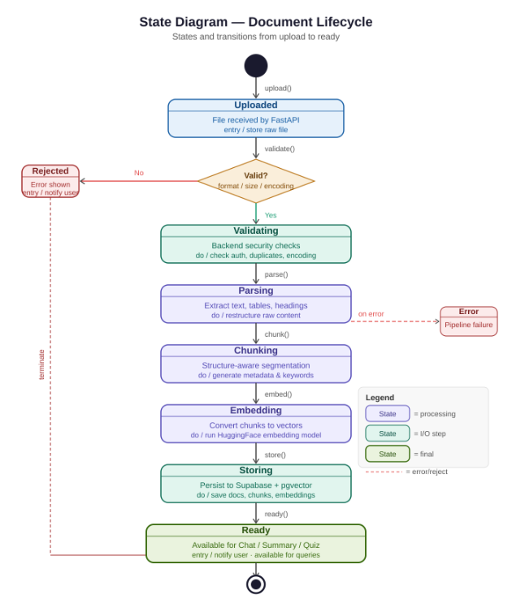

4. UI/UX Design & Prototyping

- Wireframes & Mockups:
- Main Dashboard:
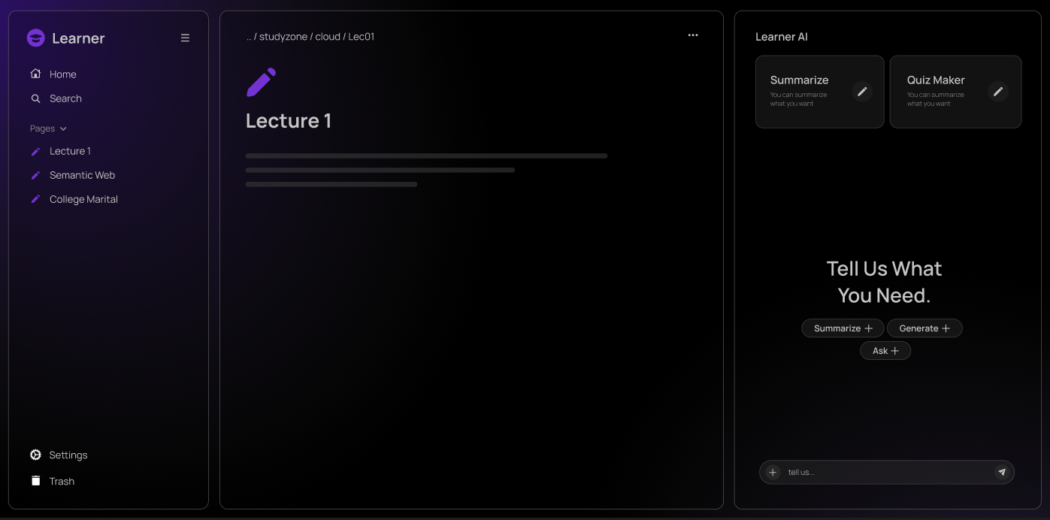
- Home Page:
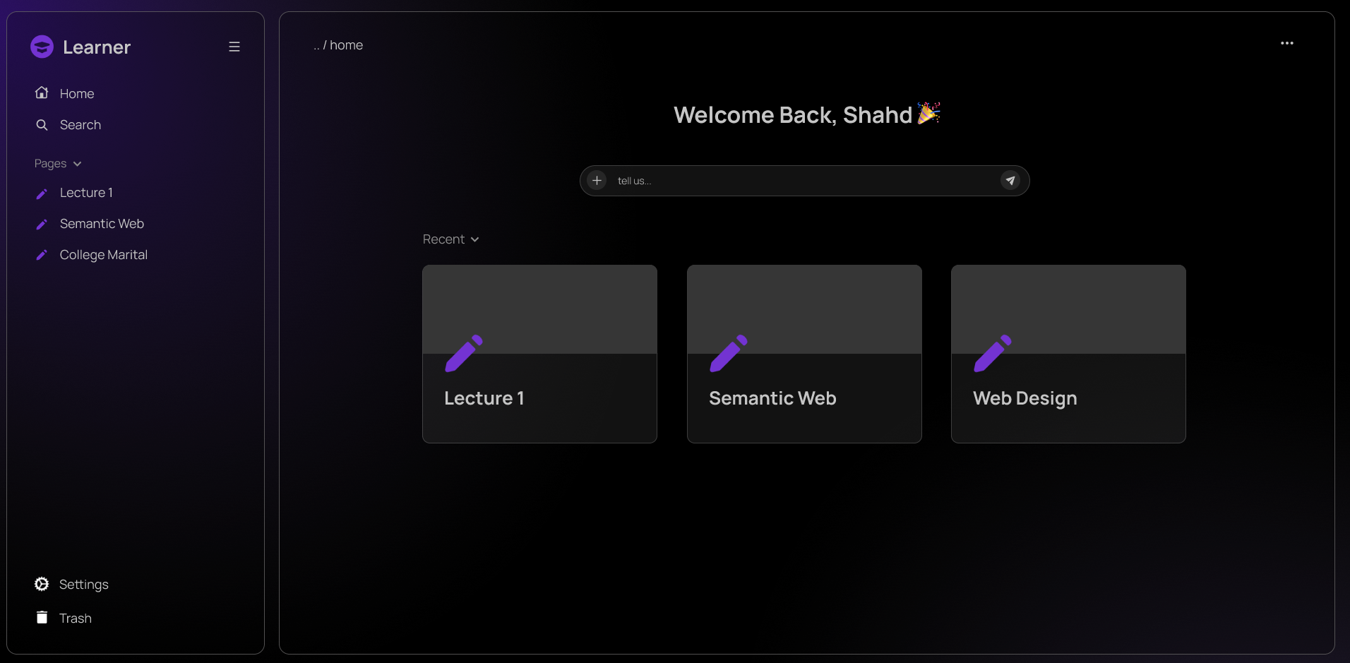

- Trash Page:
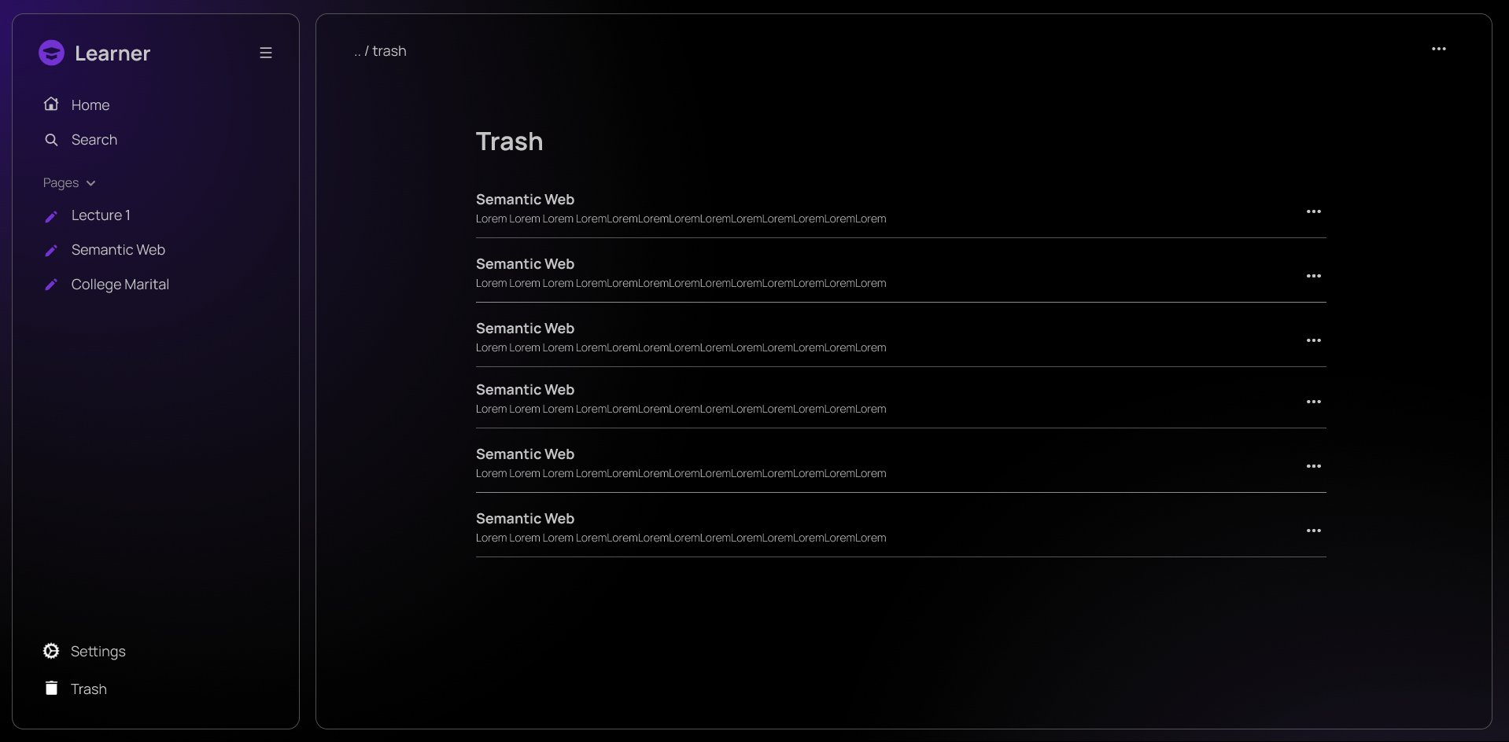
- Landing Page:
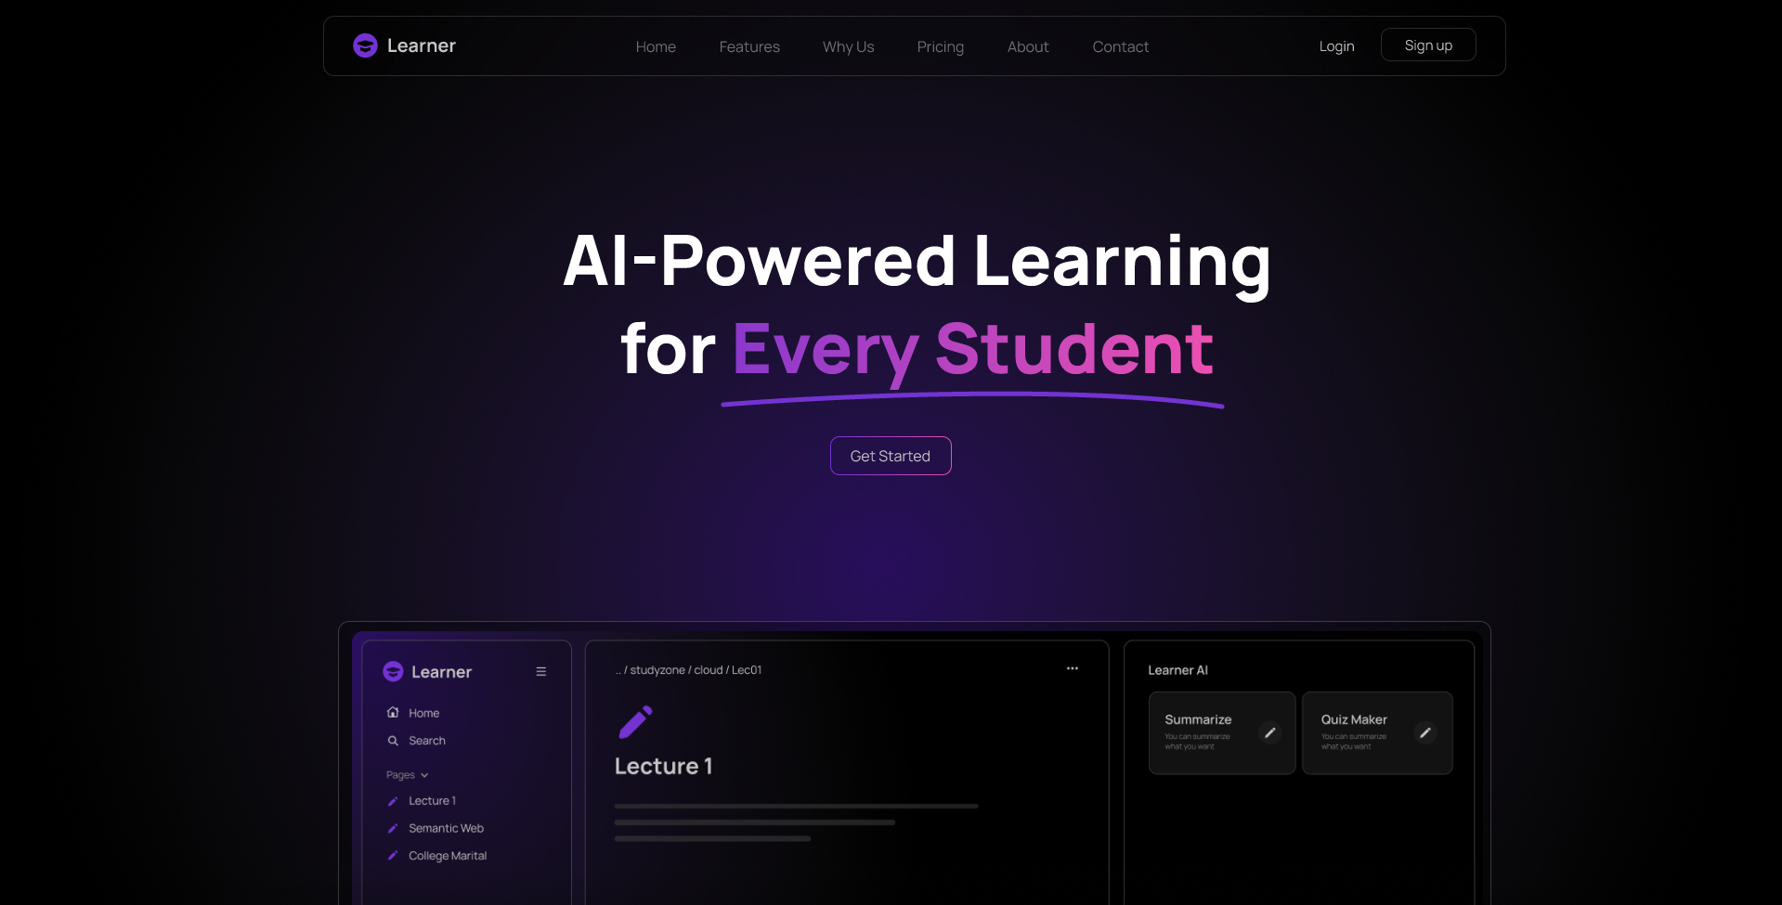

- UI/UX Guidelines:

1. Design Principles.

- Minimalist & Focused: A distraction-free environment using ample dark space to prioritize educational content and AI interactions.
- Intuitive Navigation: Familiar sidebar layout (Notion-style) ensuring a zero-learning-curve experience.
- Contextual AI: AI tools (Summarize, Quiz Maker) are integrated directly alongside the workspace, rather than hidden in menus.

2. Color Scheme

- Backgrounds: Deep Charcoal/Black (#0A0A0A to #141414) to reduce eye strain during long study sessions.
- Primary Accent: Vibrant Purple (#7333D2) for active tabs, primary actions, and highlighting AI features.
- Typography Colors: Pure White (#FFFFFF) for main text readability, and Muted Gray (#A1A1AA) for secondary text like breadcrumbs and placeholders.

3. Typography

- Font Family: Manrope (A modern, clean, and highly legible geometric sans-serif).
- Hierarchy: Bold, large headers for clear structure, and regular weights for body text to ensure comfortable reading of complex AI summaries.

4. Accessibility

- High Contrast: Strong text-to-background contrast meeting WCAG standards for visual accessibility.
- Descriptive Iconography: All key icons (Home, Settings, Trash) are paired with text labels for clear understanding.
- Touch-Friendly: Generous padding for buttons and input fields to ensure easy and accessible interaction.

5. System Deployment & Integration

- Technology Stack:
1. Frontend
🔹 Technologies:
  - Next.js (React)
  - Tailwind CSS
🔹 Description:
The Frontend is responsible for:
  - User Interface (UI)
  - User Interaction (UX)
  - Results Display (Summary/Quiz/Answers)
🔹 Why did we choose them?
  - Next.js:
    - Fast
    - SEO-friendly
    - Suitable for large applications
  - Tailwind:
    - Fast design
    - Consistent UI
    - Easy to modify

2. Backend
🔹 Technologies:
- FastAPI (Python)
🔹 Description:
- The Backend is responsible for:
- API Request Management
- Integration between the Frontend and AI
- Execution of operations (Authentication – AI Requests – Quiz Logic)
🔹 Why FastAPI?
- Very fast
- Suitable for AI systems
- Easy integration with Python libraries

3. Database
🔹 Technologies:
- Supabase (PostgreSQL + pgvector)
🔹 Description:
- The database is responsible for:
  - Storing users
  - Storing files
  - Storing results and quizzes
  - Storing embeddings
🔹 Features:
- PostgreSQL → Powerful database
- pgvector → Intelligent search (Semantic Search)
- Supabase → Ready-made + Authentication + Storage

4. AI Technologies
🔹 Tools:
- LLM APIs (such as LLaMA/GPT)
- LangChain
- LangGraph
🔹 Description:
- The AI ​​layer is responsible for:
  - Answering questions
  - Creating summaries
  - Generating quizzes
🔹 Why?
- LangChain → Process Organization
- LangGraph → Building Agentic AI
- LLM → The AI ​​Itself

5. Integration & APIs
- REST APIs using FastAPI
- Communication between:
- Frontend ↔ Backend
- Backend ↔ AI

6. Architecture Style
- Client-Server Architecture
- AI-Driven Architecture
- RAG (Retrieval-Augmented Generation)

- Deployment Diagram:

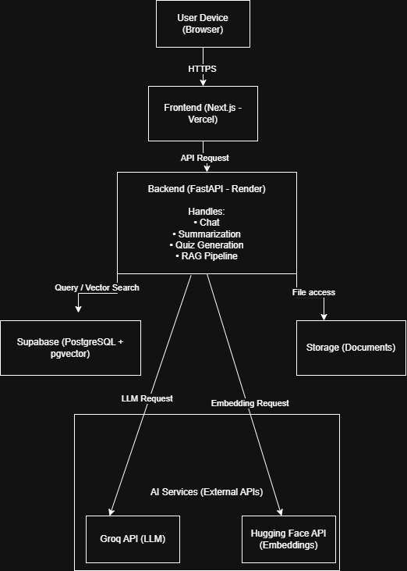
6. Additional Deliverables

- Testing & Validation:
Unit Testing:
- Frontend Components: Testing React/Tailwind UI elements (File Upload, Quiz Viewer) for correct rendering and state management.
- API Endpoints: Testing individual FastAPI routes like /upload_document and /generate_quiz for correct status codes and data validation.
- Data Ingestion: Validating text extraction, cleaning, and the "Structure Aware Chunking" logic to ensure sentences aren't cut mid-thought.
- Metadata Generation: Checking that keywords and hypothetical questions are correctly tagged to document chunks.
Integration Testing (System Level):
- RAG Pipeline Integration: Ensuring the Retriever successfully queries the Supabase pgvector database and passes relevant context to the LLM.
- Agentic Workflow: Testing the "Planner-Executor-Verifier" chain to ensure the Planner selects the right tools (summarization vs. quiz generation) based on user intent.
- Guardrails Validation: Verifying that the Gatekeeper and Auditor correctly block hallucinations and enforce JSON formatting for quizzes.
- Authentication & Security: Confirming that Supabase Row Level Security (RLS) restricts users to only seeing their own uploaded materials.

User Acceptance Testing (UAT):
- Educational Utility: Testing if AI-generated summaries and quizzes actually help students understand their specific coursework.
- Accessibility Audit: Validating ARIA patterns, keyboard navigation, and "Simplified Explanation" modes for students with disabilities.
- Instructional Accuracy: Subject matter experts review the "Faithfulness" and "Answer Relevancy" of the AI to ensure academic integrity.

AI-Specific Validation (RAGAS Framework):
Metric | Target | Validation Method +1
Faithfulness | 90%+ | Ensure the answer is grounded solely in the retrieved document chunks.
Context Precision | High | Measure if the retrieved chunks are actually relevant to the user's query.
Context Recall | High | Check if the system retrieved all necessary info to answer the question.
Answer Relevancy | High | Ensure the response directly addresses the student's question.

System Performance & Scalability Testing:
- Latency Testing: Measuring the time from "Request" to "Response" to ensure the Groq inference engine meets speed goals.
- Token Tracking Audit: Verifying that the Financial Auditing system correctly logs TPM/TPD usage per user to prevent budget overruns.
- Caching Efficiency: Testing the "Smart Caching" layer to ensure repeated questions are served from the database at zero LLM cost.

Statistical Validation of Learning Outcomes
- In the final phase, an independent samples t-test will be used to compare a Control Group (traditional study) against an Experimental Group (AI Platform users):
- Input: Post-test scores from both groups.
- Goal: A p-value of < 0.05 to prove that the AI platform creates a statistically significant improvement in learning.

- Deployment Strategy
The deployment strategy for the AI-Powered Study Platform is designed to be simple, scalable, and easy to maintain. The system uses cloud-based services to host different components separately, allowing efficient operation and future expansion.

1. Hosting Setup
The system is deployed using the following services:
- The frontend (React/Next.js) is deployed on Vercel, which provides fast and reliable hosting for web applications.
- The backend (FastAPI) is deployed on Render or Railway, where it handles user requests such as chat, summarization, and quiz generation.
- The database and storage are managed using Supabase, which stores user data, documents, and embeddings for retrieval.
- The AI models are accessed through external APIs:
  - Groq for generating responses
  - Hugging Face for creating embeddings
This separation makes the system easier to manage and update.

2. Deployment Process (CI/CD)
The project uses GitHub for version control. The deployment process works as follows:
- Developers push code updates to GitHub.
- When changes are pushed:
  - The frontend is automatically redeployed on Vercel.
  - The backend is automatically redeployed on Render or Railway.
This allows quick and reliable updates without manual deployment.

3. Environment Configuration
Sensitive data is stored using environment variables, including:
- API keys for AI services
- Database connection details
This improves security and keeps the system organized.

4. Scalability
The system can handle increasing users by:
- Scaling the backend service when needed
- Using Supabase, which supports database scaling
- Relying on external AI APIs that handle large workloads
This ensures the platform can grow over time.

5. Performance Optimization
To improve performance and reduce cost:
- The system retrieves only relevant document parts using RAG
- Frequently requested results can be cached
This reduces response time and API usage.

6. Security
Basic security measures include:
- Using HTTPS for secure communication
- User authentication through Supabase
- Protecting API endpoints from unauthorized access

7. Monitoring
The system monitors:
- API performance (response time and errors)
- AI usage and token consumption
This helps detect issues early and maintain system reliability.

